**Painting on the Periphery: Roman Wall Paintings at St. Clement, Croatia**

Completed Through: University of St. Thomas Young Scholars Grant   
Student Researcher: Madeline Olson  
Faculty Advisor: Dr. Vanessa Rousseau

**Introduction**

This study investigates and considers the history of the pigments used in wall paintings in the Roman villa on St. Clement, Croatia. Information about the rural Roman Empire and Dalmatia from the first to sixth century CE shows how St. Clement fits into the larger picture. This research project was completed as a part of the University of St. Thomas Young Scholars Grant program. The main subjects of my analysis are wall paintings found at the Soline Bay villa site. All ancient art is a product of the time period and expresses a story about the era and makers. The wall paintings express a story about the rural villas in the Roman era which is why it is vital to consider the archaeological context. The goals of this research were to expand the knowledge about rural Roman villas in provinces and enrich the understanding of pigments used at this time. This paper will cover historical, field, and scientific research conducted surrounding this topic. The historical portion of the paper includes the history of the Soline Bay villa site, rural Roman life in Dalmatia, wall paintings, and X-ray fluorescence (XRF) technology. The field research was conducted on the island of St. Clement, Croatia. The scientific research was conducted at and courtesy of the University of St. Thomas using pXRF technology to create an elemental profile. I also looked at the stylistic and artistic composition of wall painting pigments from the Soline Bay site. I had the wonderful opportunity to take part in the Croatian-American collaborative and multi-disciplinary investigations in St. Clement. The historical and field research provide the background information that is key to understanding the results of my scientific research.

**Soline Bay Site**

The Soline Bay site is located on the island of Saint Clement off the coast of Split, Croatia in the Adriatic Sea. It is situated in between the large islands of Hvar and Vis. Saint Clement is the largest island within the Pakleni Otoci archipelago with an area of 5.28 square kilometers. The name of the archipelago stems from the pine resin (paklina) used to coat bottom of ships (Begovič, Schrunk, and Ugarkovič 2012, 145). The ships docked in the many protected bays throughout the Pakleni islands. Soline Bay is situated near the middle of the island. The bay itself is protected from a majority of the wind by the island Dobri Otok. The bay is also situated at the point of the island that has the shortest span from north to south. Just like today, this placement of the bay would have been helpful for sailors in antiquity as they can use both harbors to house boats, no matter what direction the wind is coming from.

Saint Clement and the surrounding islands have a deep history due to their location in the Adriatic Sea, though few ancient sources mention them by name. Most of the information that we do have comes from the artifacts found at the Soline site and conclusions drawn from information about nearby islands. The earliest artifacts from this site are Roman coins from the late third century BCE and the early second century BCE. There is a mixture of pottery from Greece, southern Italy, northern Italy, and Hvar. There are many possibilities of how it got to Soline, some of which will be discussed in this paper. The earliest activity known in the Adriatic is when the Greeks would sail and create posts to trade with locals. This practice expanded into small towns and colonies which would eventually establish themselves as city states. The nearby island of Hvar had two well established Greek settlements. Vis, another nearby island, also had a Greek settlement that dates back to the fourth century BCE. It is highly likely that Saint Clement also had Greek settlers due to the close vicinity to these other large settlements. Greeks controlled this area, but Romans also settled in this part of the Adriatic as merchants as early as the second century BCE. The knowledge about the Greek colonies on Vis and Hvar that later turned into Roman cities provides insight that there are some ancient maritime routes in these waters. Many naval battles and conquests in this area lead to it being a strategic point. There were many maritime battles by Hvar and Vis during this time which led to many changes of who controlled and used the land which aids to explain why there are ceramics from this time period (Begovič, Schrunk, and Ugarkovič 2012, 154).

The Soline Bay site has had fifteen seasons of archaeological excavation since 2007, each uncovering more information about the history of the site. The discovered archaeological material from past excavations tells that the Soline bay area was in use from late Hellenistic/Republican period (second-first century BCE) until Late Antiquity and Early Byzantine (fourth-sixth century CE) (Begovič, Schrunk, and Ugarkovič 2012, 164). It has been agreed upon that the villa has undergone two building phases. A villa is the term for a rural house. The villa’s location and function fully indicate that this is most likely a maritime villa. There are visible remains of the villa dated to Late Antiquity that display two or more building stages reusing multiple elements from earlier buildings (Begovič, Schrunk, and Ugarkovič 2012, 143). The first construction phase of this maritime villa started in the Early Imperial age in the first century CE (Begovič, Schrunk, and Ugarkovič 2012, 151). The second phase dated from Late Antiquity up until the sixth century CE (Begovič, Schrunk, and Ugarkovič 2012, 151). It is assumed that there were different building phases due to how prosperous the economy was at the time. This large maritime villa had a north-south orientation and an orthogonal layout which was normal in Late Antique architecture (Begovič, Schrunk, and Ugarkovič 2012, 153). The Early Imperial construction had all the characteristics of a luxury villa on the Adriatic coast (Begovič, Schrunk, and Ugarkovič 2012, 153). The estates on and around the Adriatic coasts were granted to highly positioned military commanders around first century BCE-first century CE (Begovič, Schrunk, and Ugarkovič 2012, 153). Due to their location these villas on the eastern Adriatic did not have the same development as Italy (Begovič, Schrunk, and Ugarkovič 2012, 153). The Romans started to come to this part of the Adriatic to settle in large numbers after they defeated the pirates. The pirates were wiped out and the Roman Empire gained political control by the first century CE.

The Soline Bay villa is one of the largest that have been found on the island of Saint Clement. It is situated on the south side of a fertile plain on the slope of a west facing hill (Begovič, Schrunk, and Ugarkovič 2012, 149). The settlement itself was expansive as it included the many villa buildings and the fields around it. This settlement had many advantages that included good soil for cash crops, hillside terraces to support olive trees and grape vines, and a saltworks in the nearby Soline Bay. This salt work was sustained until it was covered by the approaching water levels. Today the water has gone 120 meters further inland and 2 meters higher since antiquity (Begovič, Schrunk, and Ugarkovič 2012, 147 & 153). The word “soline” itself means “salt” which helped clarify the use and resources of the Bay itself. Salt was quite important to preserve food. In maritime communities, such as this one, salted fish would have been a commodity to feed locals and sell to passing sailors. The dates of when the saltworks were built and used are unknown but have been shown to be tied to the second building phase of the villa (Begovič, Schrunk, and Ugarkovič 2012, 156). There is also a hard-white limestone quarry nearby which was mined to use and sell. The stone quarry from antiquity has a depth of 6-7 meters and width of 13-15 meters (Begovič, Schrunk, and Ugarkovič 2012, 147). A large advantage of the bay is that its importance in navigation and protection of ships. Traveling between Croatia and Italy was mostly open sea except for these few islands off the coast of Croatia. This made it so Saint Clement and surrounding islands were a place for sailors to stop, rest, and get supplies. These advantages were largely realized and utilized dating all the way back to the Greeks to control the naval routes. The quarry being so close to the sea made it easier to transport the heavy limestone by water. This quarry and ones on other islands were created and utilized when the Romans settled.

The Soline Bay villa and settlement was most likely owned by a rich Roman merchant or highly ranked military officer. Saint Clement and the surrounding islands changed hands many times depending on political change. The changing of hands created a mix of ancient populations that lived here depending on ownership and who came here to work. This field of island archaeology is unique because they have a special environment that supports crops that are not able to grow elsewhere. Islands are an important component of the network connecting sea and land resources and peoples.

**Rural Roman Life in Late Antiquity and Dalmatia**

“In constructing his house, the homeowner was quite literally building an identity.” (Hales 2009, 247). The beginning of the first century CE brought a vast Roman world that was comprised of many nationalities of people that were striving to assert their identities, social status, and basic lives. There must be a thorough historical investigation to understand the context of the Soline Bay villa and its importance to the story of the rural Roman.

The Roman Empire was very large at the beginning of the Common Era (CE). Across the Mediterranean, including the Soline Bay site, villas started to pop up along the shore after the pirates were eradicated in the first century CE (Gazda 1991, 49). The rural villas erected were used mostly for work, production, and storage (Sessa 2018, 114). Late Antiquity brought a new wave of construction and renovations across the Roman Empire (Sessa 2018, 108). The villas in the Adriatic were revitalized by Romans that immigrated to this area on the Adriatic. Romans were drawn to these areas because of the large ports nearby and the beautiful and fruitful places on the coast.

There was an initial wave of Italian settlers in the Late Republic that were mostly civilian (Wilkes 1969, 231). Once the first settlers came to Dalmatia there was continuous immigration to the area (Wilkes 1969, 232). Most of the same families controlled the trade, industry, and land even though slaves and freedmen made up about half the total population (Wilkes 1969, 234). In the second century there were new families that came in and the social climate changed (Wilkes 1969, 235). The number of freedman and slaves dropped to only make up about one-tenth of the population and this led to an increase of independent free craftsmen (Wilkes 1969, 235). These craftsmen started an intricate system of trade guilds, each that produced their respective craft. These guilds had a patron that was a member of a leading family in Salona, a large coastal community in Dalmatia. The many villas were built by high ranked military officers because they were wealthy enough to do so.

The basis of the late ancient economy was agriculturally and rurally based. Between 80-90% of the late Roman population resided in the countryside where they both grew and produced anything that they settlement could need from producing oil from the olives the grew, fermenting wine from their own grapes, and making own vessels to hold all their goods (Sessa 2018, 27). The inhabitants used physical labor to derive almost everything they ate, drank, wore, and used from the surrounding environment (Sessa 2018, 27). Late Antiquity had the greatest demand for cereals, olives, grapes, and pigs (Sessa 2018, 33). Although these were the core of people’s diets there was also enjoyment for a range of foods like legumes, fruits and vegetables, fish, eggs, cheese, and flavorings (Sessa 2018, 33). The life of peasants revolved around the seasons and the land (Sessa 2018, 21). This area of the Adriatic had certain areas that had good soil for farming, but any agricultural production was mostly just for self-sufficiency. The main crops were olives and grapes that were processed into products such as oil and wine. The owner of the Soline Bay villa settlement would have had control over the salt production and land around it to preserve fish, grow crops, and produce oil and wine. This is most likely true for the Soline Bay settlement as it is located on a small island and many ships would have been going by during different months. The farmland and salt works surrounding the site would been an important part of life and these happenings do revolve around the seasons.

The average Roman in the capital would never have heard of the thousands of the urban and rural communities that made up the rest of the empire (Hales 2009, 168). However, the elites that lived outside of the capital still regarded and thought of themselves and their homes as Romans (Hales 2009, 171). This made them feel connected with the center as they structured their whole world according to the rhetoric invented at Rome (Hales 2009, 169 & 170). Their identity rested on wrestling with the local, ethnic, and social Roman personas to create a convincing impression and fantasy of being true Romans (Hales 2009, 180). These personas led to the expansion and redefinition of what it means to be Roman in the center and the periphery. These urban centers like Salona assumed a center identity due to Rome becoming more of an idea rather than a geographical location.

Salona was the largest and most important city in Dalmatia as it was the provincial capital and held the chief port (Wilkes 1969, 220). It was also very important as the future emperor Diocletian originated from here and started the tetrarchy that reorganized the empire (Wilkes 1969, 228). This city is now called Solin and is located just north of Split, Croatia. In 40-39 BCE Roman citizens started a large community there that quickly flourished (Wilkes 1969, 220). The history of Dalmatia before the late second century CE is mostly comprised of Greek (Wilkes 1969, 220). The colony of Salona also controlled the major islands off the shore including Pharos (modern day Hvar) (Wilkes 1969, 228). The land on Hvar produced high quality wine and oil that first attracted the Greeks in the fourth century BCE (Wilkes 1969, 228). The nearby island of Brattia (modern day Brac) has high quality marble that was used in the construction of Diocletian’s palace in the fourth century CE (Wilkes 1969, 228). The most remote land of the colony of Salona was the island Issa (modern day Vis) (Wilkes 1969, 229). This island was inhabited by Roman citizens and was under military administration before becoming under the jurisdiction of Salona (Wilkes 1969, 229). Salona had a very large population that prospered due to it being a large Adriatic port serving Northern Italy and the Eastern Mediterranean (Wilkes 1969, 237). Luxury objects, metal goods, bricks and tiles, and pottery came to Salona from Italy (Wilkes 1969, 237). Salona produced and exported olive oil, wine, timber, minerals, and livestock (Wilkes 1969, 237). These ships that came in and out of this area used many of the islands that surround this area as shelter when weather was less than prime.

In Late Antiquity the domestic sphere was very central in the social institution and assisted what was important in the economy (Sessa 2018, 89). Rural landownership in Late Antiquity was the basis of wealth and labor (Sessa 2018, 30). Landlords usually spent a lot of time travelling to see all their rural properties. These rural estates were run by locals that rented the land and worked on by the tenant’s slaves or hired freedmen (Sessa 2018, 30). Seasonal migrant farm workers would also be used to provide enough manpower during harvest. Rural households depended on this seasonal labor. There were certain times of year that households included individuals that were only hired and not related to them in any way (Sessa 2018, 90). The composition of these rural households was very fluid. These tasks related to the cultivation and processing of goods were the main happenings at these rural villas. The Soline site could fit this context as it was most likely owned by a high ranked military official. This official owned the land and then the tenants rented the land to live on, farm on, and keep the production going.

Slavery was not racially or ethnically driven, anyone could be a slave and it was not a lifelong status either (Sessa 2018, 102). The marker of true poverty in Late Antiquity was to own no slaves at all (Sessa 2018, 102). There was some use of slaves and freedmen in and around the islands. I believe that the Soline Bay site had some slaves and freedmen working at or around it due to the number of tesserae that were used to make mosaics. The process of making floor mosaics was very labor intensive and hard to do. A surplus in crops led to more money to buy nicer things which could have happened at Soline which could explain the nice tesserae mosaic floors and painted walls (Sessa 2018, 22). The most durable form of decoration in villas were tesserae floor mosaics (Sessa 2018, 116). The wealthier Romans decorated the floors with mosaics of mythological figures, signs, patterns, and inscriptions (Sessa 2018, 116). Slaves and freedmen worked in all areas of building trades, which makes them a key part in the process of creating a villa in all aspects.

**Interior Decoration of the Villa**

The Roman house was very much a place for public display in both suburban and rural lives. This public display was a statement of the owner and tenants basic identities and their place in the Empire. The interior decoration was to imply that the master was present (Hales 2009, 51). The villa wanted to create an impression of the owner and the owner’s experience of the outside world (Hales 2009, 44). Houses were quite focused on how the owner and tenants looked and interacted with society. An occupied home in the Roman empire was never truly finished (Hales 2009, 99). There was always some construction or renovation happening to keep up with trends and also please the tenants and master. The reaction and construction of an identity within Roman society is represented in many ways by house plans (Hales 2009, 49). The house was a multi-faceted space that was used as an entertainment space, business office, and lobbying platform. The elites amplified domestic duties by living public lives. The house was the place where everything took place from birth through death. According to Vitruvius the elite house was open and public in nature (Hales 2009, 2). The Soline bay villa was likely set up like this so that the elite who controlled the land would allow any travelers to be welcome. The tenants were pushed by traditional Roman values to be open and public to fully participate in political and social life (Hales 2009, 35). The house was to be the center of all domestic and public life to rightfully reflect the owner and tenants (Hales 2009, 35).

**Wall Paintings**

The wall paintings that were done in the Roman Empire were usually either done in the fresco or secco technique (defined below). The writer Vitruvius speaks about the fresco and secco technique but what he says should be taken lightly. The styles, trends, and process that he writes about is how it should be in an ideal world but very few people actually followed what he said. Vitruvius’ writings are the starting point to the knowledge of the idea of perfection in the world at the time.

The fresco technique was first used by the Greeks, but the Roman Empire adapted and assimilated the technique closely. The fresco technique refers to any painting that was done while the last thin plaster layer was moist. Pigments were applied with water and were fixed to the wall when the lime in the plaster was setting. Lime is the binder for the plaster layers. The lime that was used was made by heating limestone. When calcium carbonate (CaCO3) is heated it produces calcium oxide (CaO+CO2) which is also known as quick lime. This quick lime is then mixed with water to produce calcium hydroxide (Ca (OH)2) which is known as slaked lime. The slaked lime then comes into contact with carbon dioxide (CO2) in the air and produces carbonated lime (CaCO3+H20). The lime is allowed to harden and set. During these reactions there is a large loss of water due to contraction. Lime has a high alkalinity and only a few pigments would work to use this fresco technique. The plaster would be applied in patches due to it having to be wet when the pigment was applied. The secco technique was easier to produce since it is pigments applied to dried plaster. These techniques were often mixed in a fresco-secco technique since the wet plaster dried fast and also touch ups were done in the secco technique (Kakoulli 2009, 13-26).

The Greeks heavily influenced the way that Romans approached how they built their walls and the layers to produce the wall paintings. The walls usually consisted of one to two layers of lime and sand as a base. There would then be a layer of lime and calcite (aggregates) and topped with a thin layer of chalk mixed with wax and calcium soap (Kakoulli 2009, 13). All these layers are so that the wall would have a strength and thickness to it that would help protect the inside from the elements. There were different amount and kind of layers plaster, binders, and fillers depending on the specific villa. Vitruvius lined out in his writings that there is a minimum number of layers that a wall should have and the time between to replace them, though this was rarely followed. There were different number and kinds of layers across the empire due to the materials that were available and the amount of money the homeowner wanted to spend.

The Pompeiian wall paintings which have dominated wall painting studies because of their quantity and preservation, were divided into a four-class system that was progressively dated by German scholar and archaeologist August Mau in the 19th century but they are viewed as a closed set (Hales 2009, 135). The four styles were created just to follow Pompeii’s existence and use of the painting style, so it is not totally accurate for timing (Pappalardo and Romano 2009, 9). They have been used to describe many other villas and houses even though the dates do not line up. The mixture and use of each type of style is vastly dependent on the individual houses. There were very few houses that had only one style, more often than not there were at least two of the styles in every house. Although these styles are viewed as a closed set there are trends that show these styles were used across Italy and the Roman empire itself. The First Style is characterized as very modest and is made mostly of lines and edges (Pappalardo and Romano 2009, 9). The First Style was also used to imitate the look of marble. The Second Style introduced perspective into wall painting and was created so that the area looked larger and there was also the illusion that there were panels with shutters (Pappalardo and Romano 2009, 9). The Third Style did not use perspective but instead parted the wall into different sections that figures were painted on (Pappalardo and Romano 2009, 9). The Fourth Style was a very exuberant style that combined perspective and a multitude of figures (Pappalardo and Romano 2009, 9). Although this information on Pompeii painting style is available, late Roman wall painting is different. Late Roman wall paintings tend to have simpler designs and fewer figural images. The villa had as much need for painting as a domus (urban or suburban house) did. The wall paintings were reflectors of status and really shaped what outsiders thought of the family that owned the villa (Pappalardo and Romano 2009, 8). Wall paintings also helped the family realize and shape their own identity by establishing who they thought they were and who they wanted to be (Pappalardo and Romano 2009, 8).

I was part of the excavation at the Soline Bay site in June 2019, which extended upon the excavation done in June 2018. The excavation proved to be very fruitful and this sample included a large number of coins, wall fresco, pottery, the foundation of a wall, and more. The probe was only two meters by two meters which made it curious that there was such a large number of artifacts. A few hypotheses of why there was such a large number was that it was a dumpsite or disposal site during a renovation or that the wall fell over was left with the artifacts underneath. This makes it hard to reconstruct the fragments to identify a style, but it makes it easier to do technical studies on fragments. The wall painting fragments that have been found are polychromatic but do not reflect any scenes or figural paintings. A possible theory is that these are just outlines that were painted on the walls and there were plans to add figural paintings later. Another theory is that it is the First Pompeiian style of wall paintings depicting fake marble revetment. It could be this way because it is a maritime villa that was only used seasonally or as a vacation spot. The simple blocks and bands of color are typical for the Late Roman period, but their full design cannot be reconstructed at this time. By this time there was less figural painting than larger types such as Pompeii would have been. The pigment that is used in these wall paintings show us a glimpse of what the rest of the world looked like. It is important to realize this to get a fuller picture of what life looked like in the Roman Empire.

**XRF Technology**

X-ray fluorescence (XRF) technology was used to analyze the wall painting pigments. The use of this technology made it possible to be able to know what specific elements made up the pigment itself. For my analysis I used a ThermoScientific Portable Niton XL3t GOLDD+ XRF Analyzer. This technique is useful when researchers are in the field as it can be transported easily, and it gives instant results. It also takes very little amount of time to take the readings. It is also especially useful because it is a noninvasive technique that will not harm the subject matter. The fact that it is noninvasive is also a downfall of the technique because it cannot get as precise of readings of the elemental makeup of the pigment.

**Results and Interpretation**

The archaeological excavation in Croatia led to the uncovering of hundreds of wall painting fragments. I had the opportunity to choose specific fragments to bring back to the University of St. Thomas to analyze using the XRF technology. I brought back fourteen wall painting fragments that consisted of the colors black, red, yellow, and white. I also brought back two fragments that were coated with accretion which is calcite (CaCO3) that has been bonded with the calcite substrate. This bonding happened over the course of many years and is very normal to find in the archaeological process. All the wall painting fragments that I did the X-Ray Fluorescence analysis on were from the same archaeological probe and at approximately the same depth so one can assume that the fragments are from the same time period and building. During my analysis I also did readings on the plaster and the lime accretion on the surface of the painting. When I did these readings, I found that the findings and percentage of elements were very normal from past studies. I will mainly focus on the colors yellow, red, black, and white in this discussion. The table of the colors, sample numbers, major elements, and minor elements can be found in the appendix as Table 1.

My laboratory procedure began with taking two Radiation and Online Training Sessions so I would be fully informed and certified to use the XRF analyzer. This analyzer used X-rays that are potentially dangerous if not used correctly so I completed the “US Regulations for Handheld XRF Analyzers with Radioactive Sealed Sources” and “Completed Sealed Source XRF- Radiation Safety” trainings. After I completed this training, I put sample #1 in a white bowl and placed it on the XRF stand so I would be able to keep consistency in the process. The XRF analyzer had four different elemental range modes to be able to test different subject matter. With each mode there were four different ranges of elements that it would test for: main, low, high, and light. I decided to test all four modes with all the ranges on for sample #1 so I could compare them all and make an educated move about what mode to use for the rest of the samples. When comparing them I also consulted several outside sources that used XRF to be able to know what percentages of different elements were closest to readings from different areas. The first mode I used was ‘TestAllGeo’ and put on all the ranges to try get as accurate of a reading that I could. After choosing the settings I went to ‘Analyzed’ and then pushed the button to enable the XRF analysis to be completed. I held the analyzer directly on the first sample for 60 seconds. After I did the analysis, I looked at the results and the results were slightly confusing as all of the elements were Low Detection and the Balance of Elements (Bal) were high. Low Detection means that there are only trace amounts of elements, but they are not very important in the readings itself. Balance of Elements are the things that are behind the pigment itself. In the case of these wall paintings it is most likely the plaster and binders behind it, calcium carbonate. I changed the mode to Mining Cu/Zn setting and made sure the Main, Low, High, and Light ranges on. I analyzed sample #1 for 60 seconds. When looking at these results I saw more of what I wanted and what I think that I should get. It showed more calcium and iron readings than I believed that I should get with the white pigment of sample #1. I then changed the mode to Mining Ta/Hf, had all the ranges on, and analyzed sample #1 for 30 seconds. The results were around the same as the Mining Cu/Zn mode, but it had less elements recognized, and the degree of difference was larger. I switched the mode to Soil setting, made sure all the ranges were on, and analyzed sample #1 for 30 seconds. The results from this analysis were quite different and the numbers looked way different than they should be. After all of these test runs, I decided to use the Mining Cu/Zn mode because I feel the most confident about the readings that this setting gave me. For the rest of the tests I decided to place the sample directly on the XRF stand because the analyzer would not fit into the sample bowl that I was using. I held the XRF analyzer to all samples for 60.0 seconds to keep consistency with the readings.

The results from the analysis that I did was put into a large Excel file which Professor Adam Kay of the University of St. Thomas Biology department put into a software called JMP. This software took all the readings and put them through a multi-variable statistical analysis. This produced a graph that shows where the individual samples of the different pigments are in comparison to each other. In the graphs below it shows that many of the colors are clustered together and therefore it can be assumed that the individual pigments are similar.

Red:

The red pigment analysis was done using samples 7, 9, 11, and 13. These sample numbers are shown in Figures 7, 9, 11, and 13 in the appendix also. All the readings show large amounts of calcium (Ca) along with a substantial amount of iron (Fe). The calcium reading reflects the lime plaster. The iron in the red indicates an earth pigment such as red ochre rather than vermillion or cinnabar. The graph below shows how the red pigments were clustered together. This means that they are fairly close in composition and are therefore the same pigment and made of the same material.

**Graph 1: Red Pigment JMP Analysis  
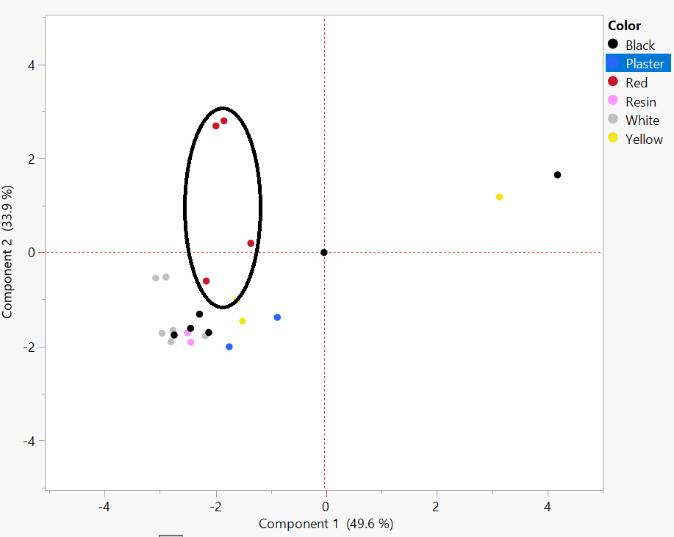**

Yellow:

The yellow pigment analysis was done using samples 4, 8, and 14. These sample numbers are shown in the appendix in Figures 4, 8, and 14. The readings of the yellow pigment shows the expected high percentage of calcium (Ca) and high levels of iron (Fe) indicated an earth pigment such as yellow ochre. The XRF analysis also concluded that there was a variety of trace elements present. The graph below shows that two of the samples are very closely clustered and just one reading that was further out. This outlier could be explained by how the XRF reading was done and there was a mix of yellow and a different pigment in the analyzing window.

**Graph 2: Yellow Pigment JMP Analysis**   
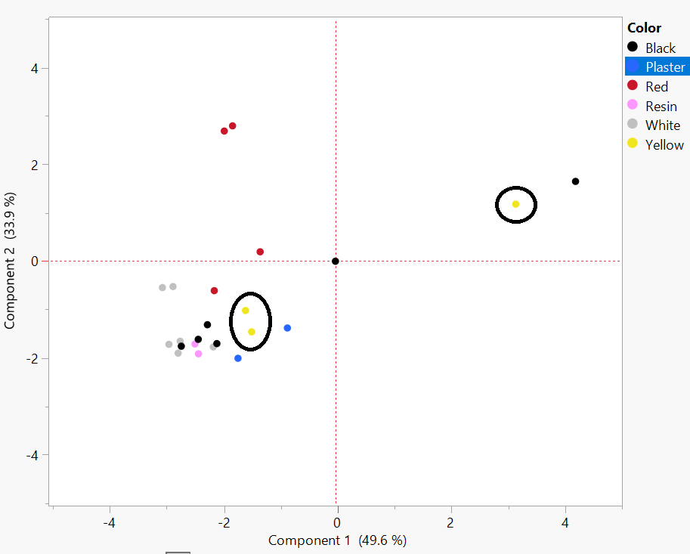

Black:

The black pigment analysis was done using samples 3, 6, 8, 9, and 10. The appendix shows pictures of these samples in Figures 3, 6, 8, 9, and 10. The readings of the black pigment show a high percentage of calcium (Ca) as expected, along with relatively high traces of iron, potassium and titanium (Table 1). The complete absence of carbon (C) suggests either a sampling error or an unusual pigment. The graph below shows that most of the samples are clustered closely together with only a few outliers. These outliers could be explained by a slight misreading in the XRF analysis.

**Graph 3: Black Pigment JMP Analysis   
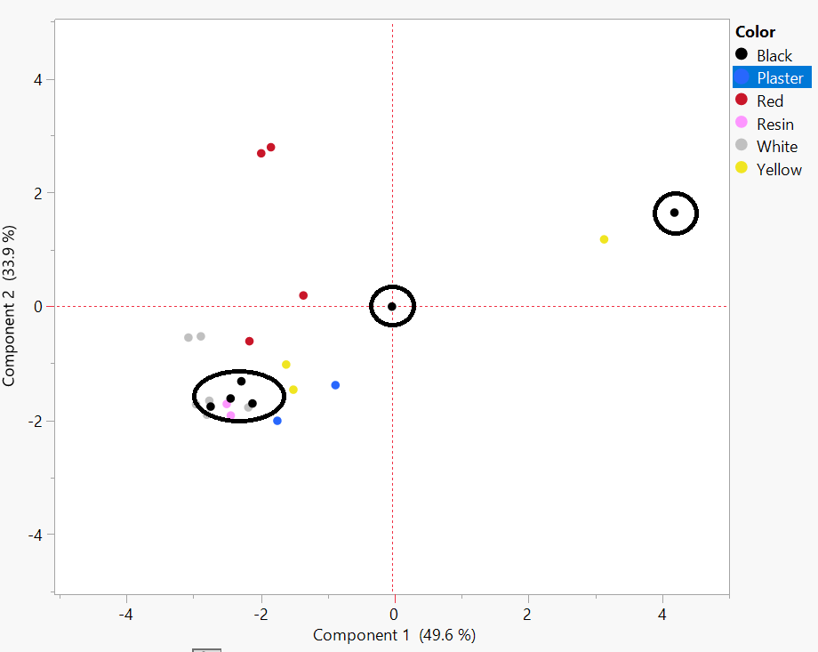**

White:

The white pigment analysis was done using samples 1, 4, 6, 7, 8, and 12. These samples are pictured in the appendix in samples 1, 4, 6, 7, 8, and 12. The XRF analysis shows that the samples are all high in calcium (Ca) with a number of trace elements. The graph below shows that all the white pigments are clustered together. This means that their elemental composition is similar, and they are most likely made up of the same pigment.

**Graph 4: White Pigment JMP Analysis   
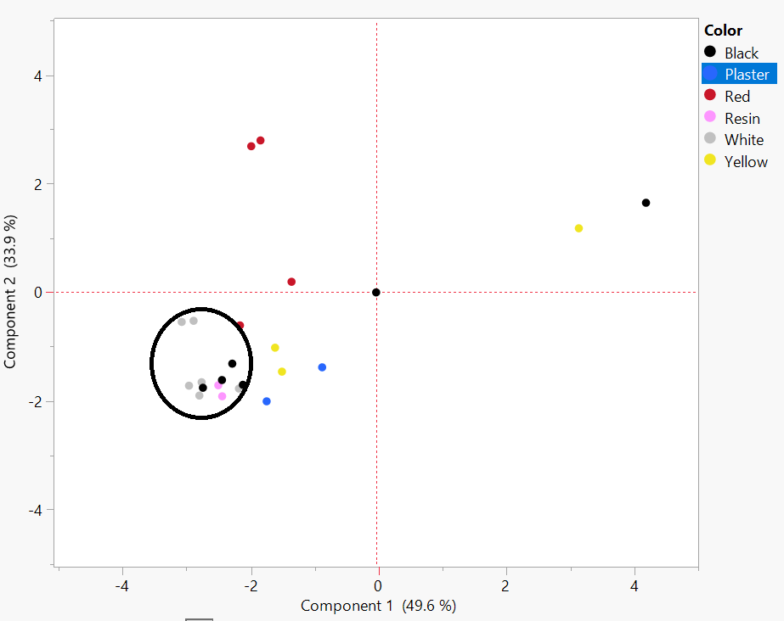**

**Summary**

The results of the XRF analysis showed that the pigments used at the Soline Bay villa site were largely typical of the time period. I compared the analysis that I did with the *Investigation of Ancient Roman Pigments by Portable X-ray Fluorescence Spectroscopy and Polarized Light Microscopy* article (Beeston and Becker 2013) and *Mineral Pigments in Archaeology: Their Analysis and the Range of Available Materials* (Siddall 2018). The iron in the red and yellow pigments indicate that these are ochres made with resources from the Earth. Many black pigments were made with soot which was easily produced at high volumes or with very dark earth, except there was a lack of carbon in these samples which is interesting to note. The high percentage of calcium across all the samples is because of the lime substrate that is applied before the pigment is applied. This percentage of calcium is most likely not related to the pigment itself, except for white which is typically made up of mostly this substrate. The low-level readings of the elements in the pigments actually do tell a lot about what else was present at the time of creating and applying these pigments. This makes the findings to be very normal for late Roman painting stylistically and compositionally. It is important to know that this is normal for the time period because it reiterates how everyday citizens of the rural Empire lived and how nearby trade routes were highly trafficked with these resources.

If I were to continue this research the next steps, I would take would be to rerun the samples so that the readings would be able to be averaged out and it is a more accurate reading along. I would also consult a chemistry professor or student who can provide more information about XRF and the elements found. I would consider Raman spectroscopy and other tools to further my understanding of these pigments and their makeup. Dr. Hilary Becker’s forthcoming book on pigments of the Roman Empire would be a vital resource. The small details and trace elements that are found by XRF analysis cannot tell us much now, but this book will start the journey to making sense of all the minor details. Information on ancient pigments has long been dispersed so this will be very useful for many years to come.

Pigment analysis has been done at many sites but very little has been done in Croatia or the Balkans as a whole. This makes this research very relevant because it is expanding the comprehensive knowledge of pigments to a further diameter of the Empire at this time. The Soline Bay villa site needs to compare to sites that are geographically and temporally distant which creates gaps between techniques, styles, and resources used for the wall paintings. This analysis and research show how this part of the Roman world is underrepresented in wall painting studies and needs so much more attention. These wall painting fragments and other material have the potential to fill the gaps in our knowledge of wall painting and regional differences in the Roman world.

**Acknowledgements**

I would first like to thank my research project advisor, Dr. Vanessa Rousseau of the UST Art History department for helping me whenever I needed and providing me with endless support. I would also like to thank Dr. Ivančica Schrunk of the UST History department and her Croatian colleagues for leading the archaeological excavation at St. Clement and assisting wherever and whenever I needed. I would like to thank Dr. Adam Kay of the UST Biology department for aiding with the pXRF analyzer, elemental profile results, and the JMP statistical analysis. I would lastly like to thank Dr. Hilary Becker of Binghamton University for sharing her extensive knowledge and insight about pigments.

**Appendix**

**Table 1: Compilation of the samples taken, and the readings received from the XRF analysis. Includes major elemental percentages and also minor/trace elemental percentages.**

|  |  |  |  |
| --- | --- | --- | --- |
| **Color** | **Sample #** | **Major (%)** | **Trace (%)** |
| Accretion | 2 | Bal 55.492 Ca 44.2 | Sr 0.022 Fe 0.158  K 0.096 |
| Accretion | 5 | Bal 59.589 Ca 39.665 | Pb 0.002 Zn 0.003 Cu 0.004 Fe 0.427  Mn 0.018 Ti 0.035 K 0.221 |
| Plaster | 5 | Bal 66.859 Ca 32.37 | Sr 0.028 Zn 0.002 Fe 0.4 Ti 0.049  K 0.287 |
| Plaster | 14 | Bal 63.098  Ca 36.163 | Sr 0.028 Pb 0.002 Fe 0.418 Mn 0.015  Cr 0.014 Ti 0.05 K 0.207 |
| Red | 7 | Bal 57.137  Fe 3.834  Ca 38.709 | Sr 0.012 As 0.039 Pb 0.014 Zn 0.013  Mn 0.019 Cr 0.013 V 0.007 Ti 0.057  K 0.14 |
| Red | 9 | Bal 58.111  Fe 2.448  Ca 39.222 | Sr 0.016 As 0.024 Pb 0.005 Zn 0.007  Ni 0.006 Cr 0.011 Ti 0.033 K 0.109 |
| Red | 11 | Bal 59.365 Ca 39.538 | Sr 0.013 As 0.008 Pb 0.004 Zn 0.004  Fe 0.883 Cr 0.008 Ti 0.031 K 0.142 |
| Red | 13 | Bal 65.844  Fe 5.809  Ca 28.061 | Sr 0.016 As 0.067 Pb 0.006 Zn 0.016  Cr 0.014 Ti 0.038 K 0.118 |
| Yellow | 4 | Bal 63.838  Fe 6.29  Ca 29.009 | Sr 0.018 As 0.002 Pb 0.003 Zn 0.005  Cu 0.045 Ni 0.012 Mn 0.032 Cr 0.021  V 0.023 Ti 0.154 K 0.545 |
| Yellow | 8 | Bal 60.398  Ca 38.279 | Sr 0.014 Pb 0.002 Zn 0.002 Cu 0.002  Fe 0.993 Cr 0.009 Ti 0.052 K 0.243 |
| Yellow | 14 | Bal 57.276  Ca 41.505 | Sr 0.013 Zn 0.002 Fe 0.959 Cr 0.006  V 0.006 Ti 0.058 K 0.171 |
| Black | 3 | Bal 58.067  Ca 41.497 | Sr 0.028 Pb 0.003 Zn 0.003 Fe 0.201  Mn 0.015 Ti 0.02 K 0.163 |
| Black | 6 | Bal 55.14  Ca 44.473 | Sr 0.007 As 0.002 Pb 0.003 Fe 0.182  Cr 0.008 Ti 0.021 K 0.154 |
| Black | 8 | Bal 55.925  Ca 43.786 | Sr 0.024 Pb 0.004 Zn 0.002 Fe 0.113  Ti 0.029 K 0.114 |
| Black | 9 | Bal 56.155  Ca 43.586 | Sr 0.01 Pb 0.003 Fe 0.116 Ti 0.032  K 0.088 |
| Black | 10 | Bal 85.443  Fe 4.146  Ca 8.121  K 1.737 | Zr 0.009 Sr 0.016 Rb 0.005 Pb 0.002  Zn 0.009 Mn 0.103 Cr 0.022 V 0.016  Ti 0.366 |
| White | 1 | Bal 52.324  Ca 47.575 | Sr 0.008 Pb 0.002 Zn 0.002 Fe 0.054  K 0.025 |
| White | 4 | Bal 50.746  Ca 49.018 | Sr 0.01 Pb 0.006 Cu 0.064 Fe 0.076  Mn 0.021 K 0.034 |
| White | 6 | Bal 58.149  Ca 41.491 | Sr 0.006 Fe 0.129 Cr 0.006 Ti 0.02  K 0.195 |
| White | 7 | Bal 51.67  Ca 48.085 | Sr 0.009 Pb 0.009 Zn 0.003 Fe 0.145  Cr 0.005 K 0.048 |
| White | 8 | Bal 62.507  Ca 37.248 | Sr 0.009 Pb 0.002 W 0.009 Zn 0.002  Fe 0.104 Ti 0.022 K 0.089 |
| White | 12 | Bal 54.143  Ca 45.732 | Sr 0.009 Pb 0.002 Fe 0.056 Ti 0.024  K 0.033 |

**Figure 1: Wall Painting Fragment sample #1 with white pigment   
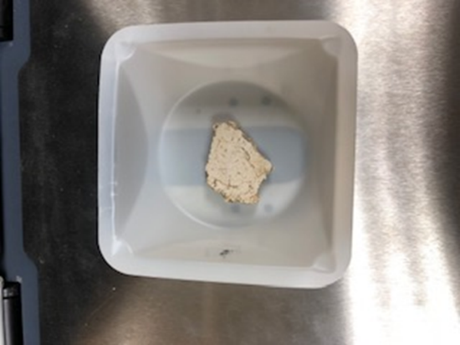**

**Figure 2: Wall Painting Fragment sample #2 with accretion   
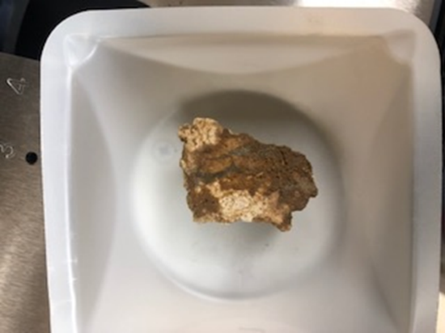**

**Figure 3: Wall Painting Fragment sample #3 with black pigment   
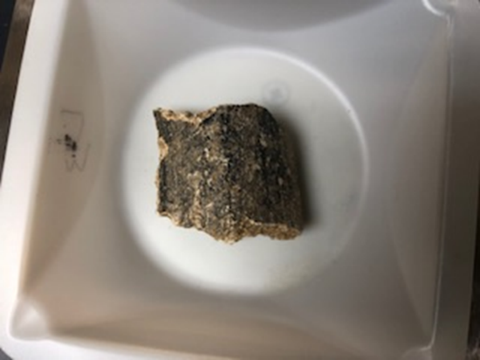**

**Figure 4: Wall Painting Fragment sample #4 with yellow and white pigment**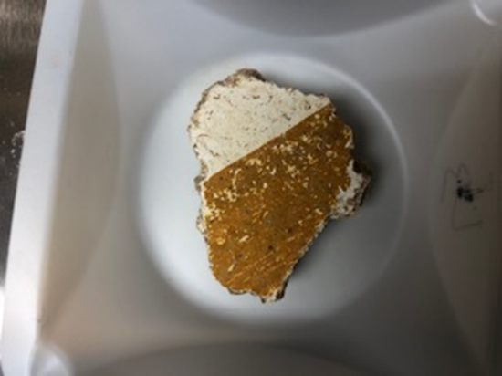

**Figure 5: Wall Painting Fragment sample #5 with plaster layers  
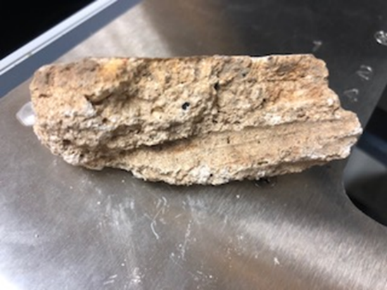**

**Figure 6: Wall Painting Fragment sample #5 with black and white pigment   
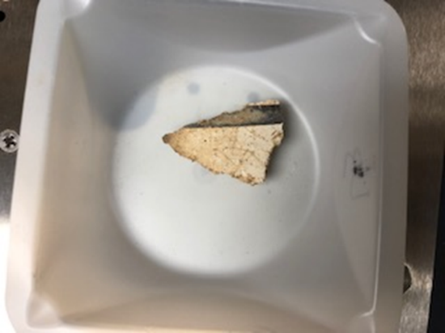**

**Figure 7: Wall Painting Fragment sample #7 with red and white pigment   
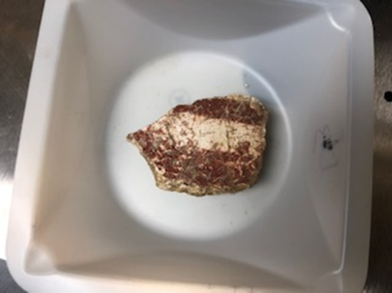**

**Figure 8: Wall Painting Fragment sample #8 with yellow, white, and black pigment** 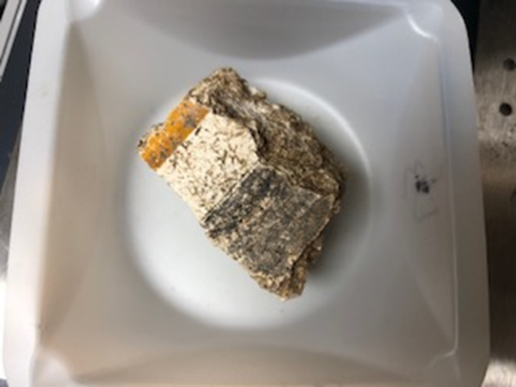

**Figure 9: Wall Painting Fragment sample #9 with red, white, and black pigment** 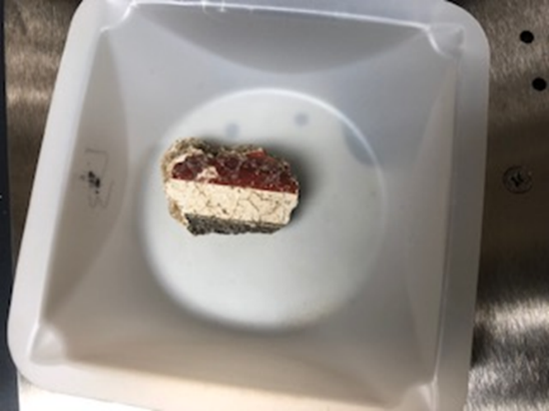

**Figure 10: Wall Painting Fragment sample #10 with black pigment   
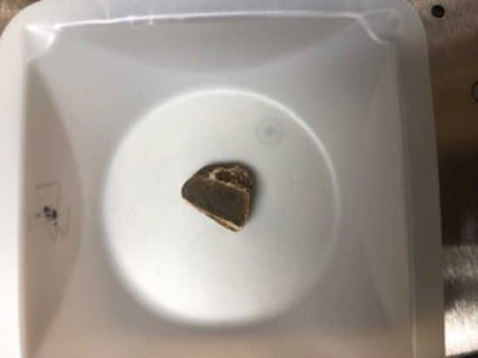**

**Figure 11: Wall Painting Fragment with sample #11 with white and red pigment** 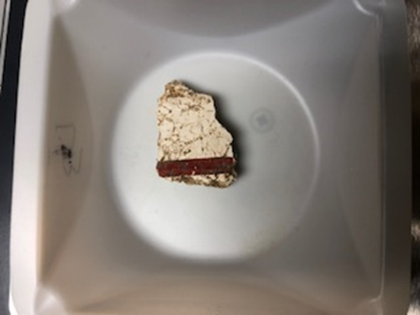

**Sample #12- Missing Picture**

**Figure 13: Wall Painting Fragment sample #13 with red pigment   
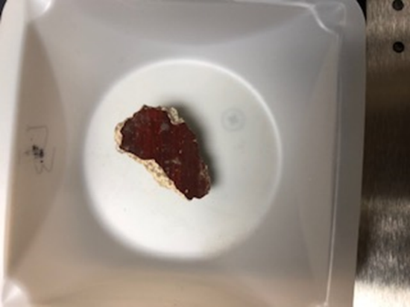**

**Figure 14: Wall Painting Fragment sample #14 with yellow and white pigment** 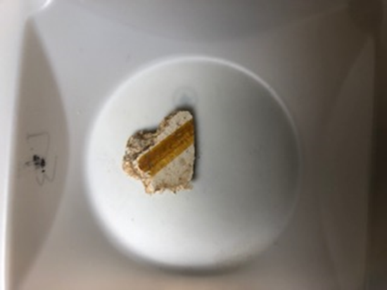

**References**

(Beeston and Becker 2013) Beeston, Ruth F and Hilary Becker. “Investigation of Roman Pigments by Portable X-ray Fluorescence Spectroscopy and Polarized Light Microscopy.” In Archaeological Chemistry VIII, 19-41. Washington D.C.: American Chemical Society, 2013.

(Begovič, Schrunk, and Ugarkovič 2012) Begovič, Vlasta and Ivančica Schrunk and Marina Ugarkovič. “Roman villa in the Soline cove on the Island of St. Clement near Hvar. Preliminary analysis of the architecture according to geophysical investigations and sondages.” In *Prilozi: Instituta za arheologiju u Zagrebu* 29, 143-166. 2012

(Clarke 2003) Clarke, John R. *Art in the Lives of Ordinary Romans: Visual Representation and Non-Elite Viewers in Italy, 100 B.C.-A.D. 315*. Oakland, Ca: University of California, 2003.

(Du Prey 1994) Du Prey, Pierre de la Ruffiniere. *The Villas of Pliny: from Antiquity to Posterity*. Chicago, IL: The University of Chicago Press, 1994.

(Gazda 1991) Gazda, Elaine K. *Roman Art in the Private Sphere: New Perspectives on the Architecture and Décor of the Domus, Villa, and Insula*. Ann Arbor, MI: University of Michigan Press, 1991.

(Wallace-Hadrill 1994) Wallace-Hadrill, Andrew. *House and Society in Pompeii and Herculaneum*. Princeton, NJ: Princeton University Press, 1994.

(Hales 2009) Hales, Shelley. *The Roman House and Social Identity*. Cambridge: Cambridge University Press, 2009.

(Kakoulli 2009) Kakoulli, Ioanna. *Greek Painting Techniques and Materials: From the Fourth to the First Century BC*. London: Archetype, 2009.

(Neudecker 2015) Neudecker, Richard. “Art in the Roman Villa.” In *A Companion to Roman Art*, edited by Barbara E. Borg, 388-405. Hoboken, NJ: John Wiley & Sons, 2015.

(Pappalardo and Romano 2009) Pappalardo, Umberto and Luciano Romano. *The Splendor of Roman Wall Paintings*. Los Angeles: J. Paul Getty Museum, 2009.

(Peterson 2015) Petersen, Lauren Hackworth. ““Art Plebea” and Non-elite Roman Art.” In *A Companion to Roman Art*, edited by Barbara E. Borg, 214-230. Hoboken, NJ: John Wiley & Sons, 2015.

(Sessa 2018) Sessa, Kristina. *Daily Life in Late Antiquity.* New York, NY: Cambridge University Press, 2018.

(Siddall 2018) Siddall, Ruth. “Mineral Pigments in Archaeology: Their Analysis and the Range of Available Materials.” *Minerals* 8, no. 5 (August 2018): 201. https://doi.org/10.3390/min8050201.

(Wilkes 1969) Wilkes, J.J. *History of the Provinces of the Roman Empire: Dalmatia*. Cambridge, MA: Harvard University Press, 1969.